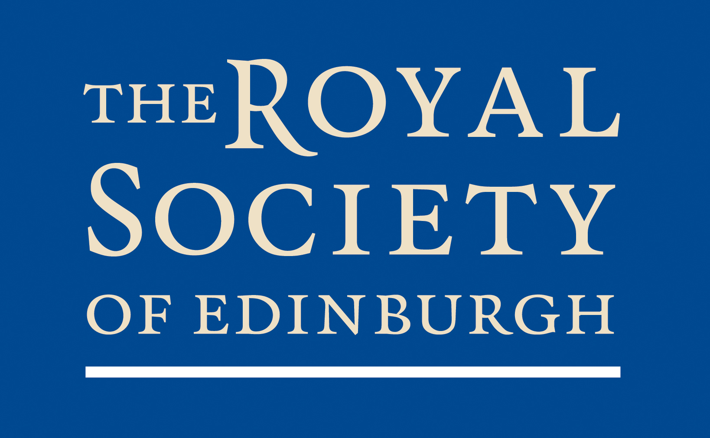

Women in STEM Dissemination Event
18 May 2012

9.00 Tea, coffee and pastries

9.30 Welcome and opening remarks
Professor Alice Brown CBE FRSE
General Secretary, The Royal Society of Edinburgh

9.35 Presentation
Professor Dame Jocelyn Bell Burnell DBE FRS FRSE
Visiting Professor of Astrophysics, University of Oxford

10.00 Responses by:
Universities Scotland representative
TBC

Dr Rabinder Buttar
Founder and CEO of ClinTec International Ltd.

10.30 Open discussion/ Q&A
All attendees

11.00 Break-out session

11.30 Break-out session summary

12.00 Panel response to discussion
Chair/Speakers

12.30 Buffet lunch/networking

