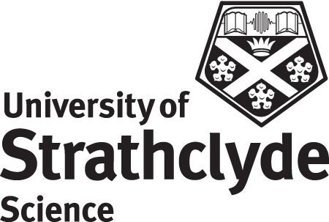 | Department of Physics  Class Information
Class Code
Class Name
Level
Credit
Teaching Staff
Lecture Times/Locations
Tutorial Times
Assessment Details
Homework Hand-in
Pre-Requisites
Syllabus
Learning Outcomes
Web-site
Recommended Reading
Departmental Disability Contacts |  | Ms K. Munro – JA 8.04 kirsten.munro@strath.ac.uk  Dr T. Han – JA 8.05 t.han@strath.ac.uk

