

###### General AV Specification

Audio Visual Equipment – New Install.

**General AV Information**

The University of Strathclyde requires several AV systems to be installed within the new Teaching & Learning building utilising and combining the Architecture and Colville buildings.

This specification of AV requirements is for the design, supply, installation, testing and commissioning of all AV systems within the teaching & learning spaces. This will include lecture theatres, seminar rooms, meeting rooms, configurable TEAL spaces. In addition to the teaching environments it is envisaged that a room booking and room utilisation screen systems will be sourced and installed at the entrance not only to each floor but the entrance to each room. It was discussed that various screens and video walls may be installed within the social and gathering areas but this is still to be confirmed.

This document will outline the various different system display templates which should be integrated and adapted with the inclusion of additional screens to encapsulate all functions required in each space within the building.

The final design and specification will be created in collaboration between the project design team, Central room bookings, LSS AV design team and The Learning and teaching focus group.

The undernoted table below indicates the relevant rooms that will require AV with the specific AV template and additional options required to fulfil the building’s scope.

|  |  |  |  |  |
| --- | --- | --- | --- | --- |
| Room No. | Designation | Size (Seat) | Design Template | Options required |
| CV805 | Small Meeting space | 6 | T2 | Laptop connection only |
| 7th Floor | | | | |
| CV705 | Small Meeting space | 6 | T2 | Credenza to house PC |
| 6th Floor | | | | |
| CV605 | Small Meeting space | 6 | T2 | Credenza to house PC |
| CV651 | Group work area | 47 | T4 | 5 additional dual group stations |
| CV652 | Small teach | 25 | T1 |  |
| CV653 | Small teach | 13 | T1 |  |
| CV655 | Small teach | 20 | T1 |  |
| CV656 | Breakout | 44 | T2 | 4 small individual areas |
| CV657 | Small teach | 19 | T1 |  |
| CV661 | Small teach | 17 | T1 |  |
| CV663 | Group work area | 90 | T4 | 6 additional dual group stations |
| CV664 | Breakout | 4 | T2 |  |
| CV667 | Small teach | 7 | T2 |  |
| CV669 | Small teach | 6 | T2 |  |
| CV670 | Breakout | 13 | T1 |  |
| CV671 | Small teach | 6 | T2 |  |
| CV673 | Small teach | 7 | T2 |  |
| CV674 | Small teach | 6 | T2 |  |
| CV675 | Breakout | 7 | T2 |  |
| 5th Floor | | | | |
| CV505 | Small Meeting space | 6 | T2 | Credenza to house PC |
| CV551 | Group work area | 46 | T4 | 3 additional dual group stations |
| CV551A | Small teach | 6 | T2 |  |
| CV551B | Small teach | 6 | T2 |  |
| CV552 | Small teach | 11 | T2 |  |
| CV553 | Small teach | 11 | T2 |  |
| CV555 |  | 19 | T1 |  |
| CV556 | Breakout | 21 | T1 | 3 additional single group stations |
| CV557 | Small teach | 19 | T1 |  |
| CV558 | Breakout | 21 | T1 | 3 additional single group stations |
| CV559 | Small teach | 19 | T1 |  |
| CV562 | Small teach | 11 | T2 |  |
| CV564 | Group work area | 75 | T4 | 6 additional dual group stations |
| CV565 | Breakout | 4 | T2 |  |
| CV566 | Breakout | 4 | T2 |  |
| CV568 | Breakout | 5 | T2 |  |
| CV570 | Small teach | 9 | T2 |  |
| CV572 | Breakout | 5 | T2 |  |
| CV574 | Small teach | 9 | T2 |  |
| CV575 | Breakout | 5 | T2 |  |
| CV577 | Small teach | 9 | T2 |  |
| CV578 | Breakout | 7 | T2 |  |
| 4th Floor | | | | |
| CV424 | Lecture Theatre | 100 | T4 |  |
| CV427 | Teaching room | 60 | T4 |  |
| CV428 | Teaching room | 60 | T4 |  |
| CV429 | Speakers corner |  | T1 | With PA |
| CV454 | TO BE CONFIRMED |  |  |  |
| CV453 | Group work area | 80 | GW | 6 Single group stations |
| CV457 | Lecture theatre | 80 | T4 |  |
| CV461 | Breakout | 5 | T2 |  |
| CV462 | Small teach | 30 | T1 |  |
| CV463 | Breakout | 5 | T2 |  |
| CV464 | Breakout | 5 | T2 |  |
| CV465 | Small teach | 29 | T1 |  |
| CV466 | Breakout | 6 | T2 |  |
| CV467 | Breakout | 5 | T2 |  |
| CV468 | Small teach | 20 | T1 |  |
| 3rd Floor | | | | |
| CV325a | Lecture theatre | 201 | T4 | 2 Additional repeater screens, ability to combine with CV325b |
| CV325b | Lecture theatre | 201 | T4 | 2 Additional repeater screens, ability to combine with CV325a |
| CV326 | Teaching Room | 45 | T4 |  |
| CV327 | Teaching Room | 100 | T4 | 2 additional Projectors. |
| CV330 | Teaching Room | 90 | T4 |  |
| CV332 | Teaching room | 240 | T4 | 6 additional dual group stations |
|  |  |  |  |  |
|  |  |  |  |  |
|  |  |  |  |  |
|  |  |  |  |  |

**Template AV Information**

**T1 Single Laser Projector**

This template forms the basis of a small basic teaching presentation system which facilitates the following source connections listed in the table below.

|  |  |  |
| --- | --- | --- |
| **Source Equipment** | **Connection** | **Notes** |
| Temporary PC Laptop input | HDMI | Mounted on the wall or in a floor box; 3m umbilical cord (incl. embedded audio) |
| Temporary PC Laptop input | VGA & Audio | Mounted on the wall or in a floor box; 3m umbilical cord (incl. audio) |
| Wireless gateway for ‘Bring Your Own Device’ (BYoD) | HDMI | To enable lecturer/ academic staff to connect tablets, phones, etc., into system |
| Remote monitoring camera | PoE | Ceiling mounted to assist technical support and room monitoring |
| AV over IP system | HDMI | To facilitate the streaming from another location within the University Campus. |

**Display Systems**

|  |  |  |
| --- | --- | --- |
| **Display Device** | **Connxn** | **Notes** |
| Data-Video Projector | HDMI | To be ceiling-mounted.  This projector will be at 4K/ UHD resolution inc Phosphor Laser technology.  It must have a contrast ratio of >= 13,000:1????? and an ANSI lumen value of >= 4500 ANSI.  Pole mounted box to an AV over IP Decoder. |
| Projection Screen |  | To be wall-mounted on the teaching/ presentation wall; this will be a fixed frame screen Size dependent on maximum viewing distance with appropriate black borders. |

In this template we will require a ceiling mounted projector that utilises Phosphor Laser technology to project the source material onto a fixed frame screen. We have specified a Laser phosphor projector as it doesn’t contain the normal replaceable bulbs (i.e. every 2000 hours) and only need the laser light source changed every 20,000 hours therefore should provide us with a minimum of 5 years zero cost running. The projector should have a minimum of 5-year manufacturer warranty.

The projector should display on a 16:10 ratio.

**Video Signal**

All video signals as they are different formats will be connected into an appropriate scaling switcher that will be configured to optimise the native resolution of the projector.

The switcher should be capable of outputting on an HDBT format to allow the transmission of the video signal over structured cable up to 70 mtrs.

The switcher should also have the capability of being connected to the University LAN to allow remote diagnostics and configuration.

**Audio Signal**

All source audio should be connected and routed via the video switcher with the relative selected source audio being connected to an external audio amplifier.

The amplifier will be connected to 2 wall mounted speakers in either corner of the projection wall.

There is no voice reinforcement within this design.

**Control System**

|  |  |  |
| --- | --- | --- |
| **Control System** |  | **Notes** |
| 6 Button AMX Massio wall panel |  | Wall mounted to the lower RHS of the screen. |

Control will be obtained by using a small unobtrusive 6 button wall panel with rotary volume control mounted to the RHS of the screen and be compatible with the University Room monitoring system. It will provide the following selections-

* Power On/Off
* Laptop HDMI selection
* Laptop VGA selection
* BYoD selection
* External stream selection.

**DDA System**

A small Infra-red radiator hard of hearing system will be installed in the room which meets the University DDA requirement.

|  |  |  |
| --- | --- | --- |
| **DDA System** |  | **Notes** |
| Sennheiser small Infra-red Radiator system ( inc Headset) |  | Wall mounted to RHS of room. |
| White hanging Condenser microphone |  | Mounted in centre of room hanging from ceiling.. |

**Lectern**

This lectern will be of University design capable of housing an AV equipment rack. The lectern should have the capability of allowing the top surface to be raised and lowered to meet the stringent DDA regulations. The top of the lectern should have installed a suitable sized confidence monitor on an articulated arm, desk mounted visualizer and facilities wedge.

The facilities wedge will contain 2 x 13amp mains sockets with incorporated high current USB charging sockets, USB socket connected directly to the rack mounted PC and 3.5mm audio socket for a small external MP3 recorder to be connected for lecture audio recording. A suitable sized cable grommet will allow the HDMI and VGA & Audio umbilical cable.

|  |  |  |
| --- | --- | --- |
| **Lectern** |  | **Notes** |
| University designed custom build lectern with no writing surface. |  | Removable rack of minimum 13u size to house all AV equipment and a university PC. |
| Custom made facilities wedge. |  | Mounted on the front centre of the top surface. |

**T2 65” LCD Screen**

This template forms the basis of a medium dual basic teaching presentation system which facilitates the following source connections listed in the table below.

|  |  |  |
| --- | --- | --- |
| **Source Equipment** | **Connection** | **Notes** |
| Temporary PC Laptop input | HDMI | Mounted on the wall or in a floor box; 3m umbilical cord (incl. embedded audio) |
| Temporary PC Laptop input | VGA & Audio | Mounted on the wall or in a floor box; 3m umbilical cord (incl. audio) |
| Wireless gateway for ‘Bring Your Own Device’ (BYoD) | HDMI | To enable lecturer/ academic staff to connect tablets, phones, etc., into system |
| Remote monitoring camera | PoE | Ceiling mounted to assist technical support and room monitoring |
| AV over IP system | HDMI | To facilitate the streaming from another location within the University Campus. |

**Display Systems**

|  |  |  |
| --- | --- | --- |
| **Display Device** | **Connxn** | **Notes** |
| 65” LED Screen | HDMI | To be wall -mounted.  The BYoD receiver and AV over IP Decoder will be mounted to the wall behind the screen |

This template will utilise wall mounted 65” LED technology screen.

**Video Signal**

This template will utilise all the inputs on the display screen so no external video routing is required.

**Audio Signal**

Audio for these rooms will utilise the internal speakers on the screen.

There is no voice reinforcement within this design.

**Control System**

|  |  |  |
| --- | --- | --- |
| **Control System** |  | **Notes** |
| 6 Button AMX Massio wall panel |  | Wall mounted to the lower RHS of the screen. |

Control will be obtained by using a small unobtrusive 6 button wall panel with rotary volume control mounted to the RHS of the screen and be compatible with the University Room monitoring system. It will provide the following selections-

* Power On/Off
* Laptop HDMI selection
* Laptop VGA selection
* BYoD selection
* External stream selection.

**DDA System**

A small Infra-red radiator hard of hearing system will be installed in the room which meets the University DDA requirement.

|  |  |  |
| --- | --- | --- |
| **DDA System** |  | **Notes** |
| Sennheiser small Infra-red Radiator system ( inc Headset) |  | Wall mounted to RHS of room. |

**T3 Dual 65” LCD**

This template forms the basis of a medium size dual teaching presentation system which facilitates the following source connections listed in the table below.

|  |  |  |
| --- | --- | --- |
| **Source Equipment** | **Connection** | **Notes** |
| Dedicated PC | HDMI | At lectern/ front desk; Provided by University IT Services; will include PC screen, keyboard and mouse |
| Temporary PC Laptop input | HDMI | At lectern/ front desk; 3m umbilical cord (incl. embedded audio) |
| Temporary PC Laptop input | VGA & Audio | At lectern/ front desk; 3m umbilical cord (incl. embedded audio) |
| Wireless gateway for ‘Bring Your Own Device’ (BYoD) | HDMI | At lectern/ front desk; to enable lecturer/ academic staff to connect tablets, phones, etc., into system |
| USB flash drive hub | USB | At lectern/ front desk; 2-port hub to input flash drives into PC |
| Remote monitoring camera | PoE | Ceiling mounted to assist technical support and room monitoring |
| Desk mounted Vizualiser | HDMI | At lectern/ front desk |

**Display Systems**

|  |  |  |
| --- | --- | --- |
| **Display Device** | **Connxn** | **Notes** |
| 65” LED Screen | HDMI | To be wall -mounted. |

This template will utilize wall mounted 65” LCD screens.

**Video Signal**

Due to the different formats of video signal and also the requirement to display different signals on both the 2 main presentation screens simultaneously the switching mechanism must be of a matrix variety. It must also have the ability of scaling the incoming video to optimise the native resolution of the screens. The matrix switcher should be capable of outputting on an HDBT format to allow the transmission of the video signal over structured cable up to 70 metres.

The switcher should have the capability of being connected to the University LAN to allow remote diagnostics and configuration.

**Audio Signal Routing**

The audio signal from all devices including lectern microphone, tie clip/ handheld radio microphone and source material from the matrix switcher will be routed through a fully programmable digital sound processor. This processor will feed the front of house wall mounted speakers for source material, ceiling speakers for voice reinforcement and small amount of source (quantity determined by room size) and the hard of hearing systems. The processor will be capable of providing multiple ceiling circuits and facilitate the addition of delays to the ceiling speakers to create a rich natural sound through the teaching space.

The processor should have the capability of being connected to the University LAN to allow remote diagnostics and configuration

**Control System**

Control will be obtained by using a custom designed 7” desk mounted touch panel and processor system. This system needs to be network compatible and also be compatible with the pre-existing University room monitoring system. The touch panel layout design will be created in accordance with the University standardised layout and functionality profile ensuring it matches existing rooms previously installed on campus.

**DDA System**

This template incorporates 2 different types of technology:

* A small Infra-red radiator hard of hearing system manufactured by Sennheiser which meets the university standardisation process.
* A floor mounted induction loop designed to minimise overspill to the adjacent rooms. This design will incorporate an array style and not a perimeter loop.

|  |  |  |
| --- | --- | --- |
| **DDA System** |  | **Notes** |
| Sennheiser small Infra-red Radiator system ( inc Headset) |  | Wall mounted to RHS of room. |
| Array style floor mounted loop system |  | Installed prior to the final floor finish. |

**Lectern**

This lectern will be of University design capable of housing an AV equipment rack. The lectern should have the capability of allowing the top surface to be raised and lowered to meet the stringent DDA regulations. The top of the lectern should have installed a suitable sized confidence monitor on an articulated arm, a desk mounted visualizer and facilities wedge. The facilities wedge will contain 2 x 13amp mains sockets with incorporated high current USB charging sockets, USB socket connected directly to the rack mounted PC and 3.5mm audio socket for a small external MP3 recorder to be connected to aid lecture audio recording.

A suitable sized cable grommet will allow the HDMI and VGA & Audio umbilical cable.

|  |  |  |
| --- | --- | --- |
| **Lectern** |  | **Notes** |
| University designed custom build lectern with no writing surface. |  | Removable rack of minimum 13u size to house all AV equipment and a university PC. |
| Custom made facilities wedge. |  | Mounted on the front centre of the top surface. |

**T4 Dual Laser Projector**

This template forms the basis of a Large size teaching presentation system which facilitates the following source connections listed in the table below. Dependent on the room size additional repeater screens may be positioned to aid viewing angles. The system will have the ability to send or receive images from other locations across campus.

|  |  |  |
| --- | --- | --- |
| **Source Equipment** | **Connection** | **Notes** |
| Dedicated PC | HDMI | At lectern/ front desk; Provided by University IT Services; will include PC screen, keyboard and mouse |
| Temporary PC Laptop input | HDMI | At lectern/ front desk; 3m umbilical cord (incl. embedded audio) |
| Temporary PC Laptop input | VGA & Audio | At lectern/ front desk; 3m umbilical cord (incl. embedded audio) |
| Wireless gateway for ‘Bring Your Own Device’ (BYoD) | HDMI | At lectern/ front desk; to enable lecturer/ academic staff to connect tablets, phones, etc., into system |
| USB flash drive hub | USB | At lectern/ front desk; 2-port hub to input flash drives into PC |
| Remote monitoring camera | PoE | Ceiling mounted to assist technical support and room monitoring |
| Visualizer Writing surface system | HDMI | At lectern/ front desk and ceiling mounted camera. |

**Display Systems**

|  |  |  |
| --- | --- | --- |
| **Display Device** | **Connxn** | **Notes** |
| Data-Video Projector | HDMI | To be ceiling-mounted.  This projector will be at 4K/ UHD resolution inc Phosphor Laser technology.  It must have a contrast ratio of >= 13,000:1????? and an ANSI lumen value of >= 5500 ANSI.  Pole mounted box to contain AV over IP Decoder. |
| Projection Screen |  | To be wall-mounted on the teaching/ presentation wall; this will be a fixed frame screen Size dependant on maximum viewing distance with appropriate black borders. |

In this template we will require ceiling mounted projectors that utilise Phosphor Laser technology to project the source material onto fixed frame screens. We have specified laser phosphor projectors as they don’t contain the normal replaceable bulbs (i.e. every 2000 hours) and only need the laser light source changed every 20,000 hours therefore should provide us with a minimum of 5 years zero cost running. The projector should have a minimum of 5-year manufacturer warranty.

The projector should display on a 16:10 ratio.

**Video Signal**

Due to the different formats of video signal and also the requirement to display different signals on both the 2 main presentation screens simultaneously the switching mechanism must be of a matrix variety. It must also have the ability of scaling the incoming video to optimise the native resolution of the projectors. It must also be of sufficient size to allow additional screens to be installed and fed with the relevant video signals should the size of the room dictate. The matrix switcher should be capable of outputting on an HDBT format to allow the transmission of the video signal over structured cable up to 70 mtrs.

The switcher should have the capability of being connected to the University LAN to allow remote diagnostics and configuration.

**Audio Signal Routing**

The audio signal from all devices including lectern microphone, tie clip/ handheld radio microphone and source material from the matrix switcher will be routed through a fully programmable digital sound processor. This processor will feed the front of house wall mounted speakers for source material, ceiling speakers for voice reinforcement and small amount of source (quantity determined by room size) and the hard of hearing systems. The processor will be capable of providing multiple ceiling circuits and facilitate the addition of delays to the ceiling speakers to create a rich natural sound through the teaching space.

The processor should have the capability of being connected to the University LAN to allow remote diagnostics and configuration

**Control System**

Control will be obtained by using a custom designed 10” desk mounted touch panel and processor system. This system needs to be network compatible and also be compatible with pre-existing University room monitoring system. The touch panel layout design will be created in accordance with the University standardised layout and functionality profile ensuring it matches existing rooms previously installed on campus.

**DDA System**

This template incorporates 2 different types of technology:

* A small Infra-red radiator hard of hearing system manufactured by Sennheiser which meets the university standardisation process.
* A floor mounted induction loop designed to minimise overspill to the adjacent rooms. This design will incorporate an array style and not a perimeter loop.

|  |  |  |
| --- | --- | --- |
| **DDA System** |  | **Notes** |
| Sennheiser small Infra-red Radiator system ( inc Headset) |  | Wall mounted to RHS of room. |
| Array style floor mounted loop system |  | Installed prior to the final floor finish. |

**Lectern**

This lectern will be of University design capable of housing an AV equipment rack. The lectern should have the capability of allowing the top surface to be raised and lowered to meet the stringent DDA regulations. The top of the lectern should have installed a suitable sized confidence monitor on an articulated arm, a fully fitted rear illuminated glass writing surface and facilities wedge. The facilities wedge will contain 2 x 13amp mains sockets with incorporated high current USB charging sockets, USB socket connected directly to the rack mounted PC, an USB socket to enable image capture from the ceiling mounted capture camera and 3.5mm audio socket for a small external MP3 recorder to be connected to aid lecture audio recording.

A suitable sized cable grommet will allow the HDMI and VGA & Audio umbilical cable.

|  |  |  |
| --- | --- | --- |
| **Lectern** |  | **Notes** |
| University designed custom build lectern with no writing surface. |  | Removable rack of minimum 13u size to house all AV equipment and a university PC. |
| Custom made facilities wedge. |  | Mounted on the front centre of the top surface. |

**Room Layout Information**

**3rd Floor**

**Room 326**

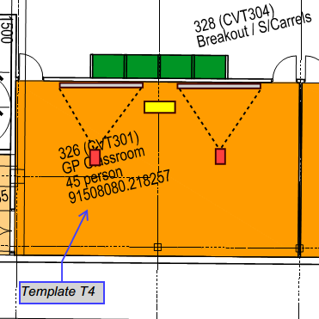

|  |  |  |
| --- | --- | --- |
| Department | Comments | Actioned |
|  |  |  |
|  |  |  |
|  |  |  |
|  |  |  |
|  |  |  |

**Room 327**

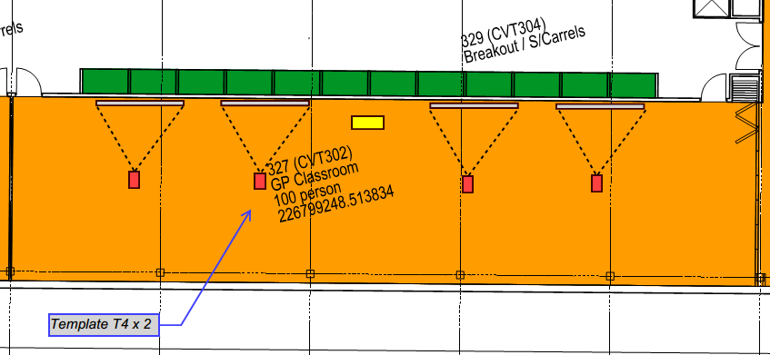

|  |  |  |
| --- | --- | --- |
| Department | Comments | Actioned |
| AV | Add the ability to link to 330 |  |
|  |  |  |
|  |  |  |
|  |  |  |
|  |  |  |

**Room330**

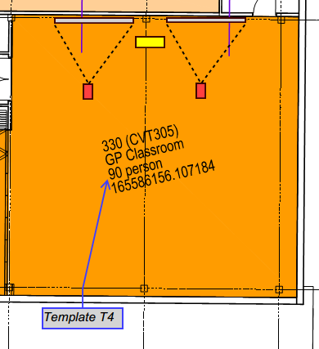

|  |  |  |
| --- | --- | --- |
| Department | Comments | Actioned |
| AV + Group | Move Projectors to display on RHS wall. |  |
| AV+ Group | Add the ability to combine with 327. |  |
|  |  |  |
|  |  |  |
|  |  |  |

**Room 332**

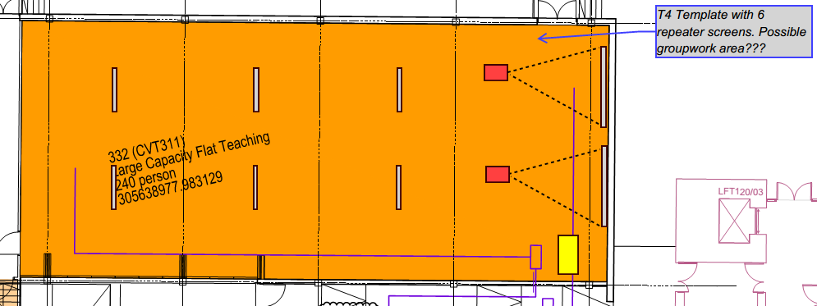

|  |  |  |
| --- | --- | --- |
| Department | Comments | Actioned |
|  |  |  |
|  |  |  |
|  |  |  |
|  |  |  |
|  |  |  |

**Room 325**

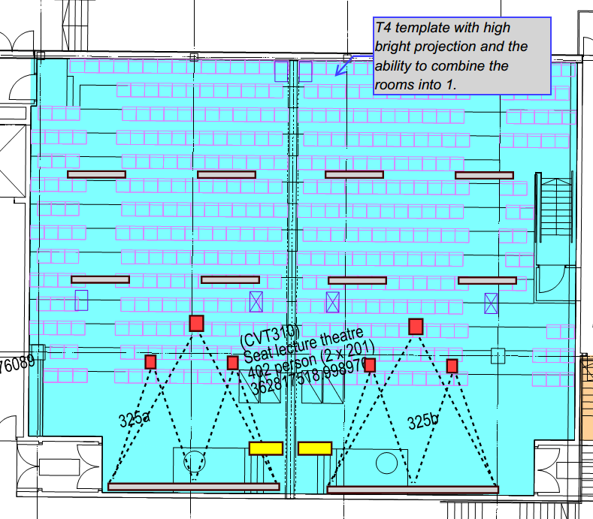

|  |  |  |
| --- | --- | --- |
| Department | Comments | Actioned |
|  |  |  |
|  |  |  |
|  |  |  |
|  |  |  |
|  |  |  |

**4th Floor**

**Room 424**

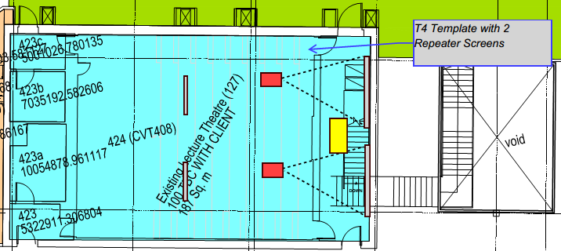

|  |  |  |
| --- | --- | --- |
| Department | Comments | Actioned |
|  |  |  |
|  |  |  |
|  |  |  |
|  |  |  |
|  |  |  |

**Room 427**

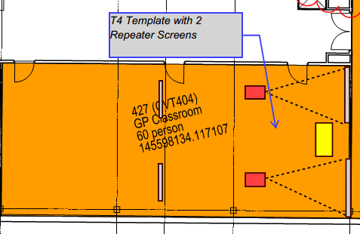

|  |  |  |
| --- | --- | --- |
| Department | Comments | Actioned |
|  |  |  |
|  |  |  |
|  |  |  |
|  |  |  |
|  |  |  |

**Room 428**

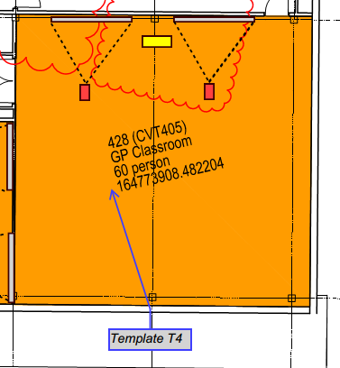

|  |  |  |
| --- | --- | --- |
| Department | Comments | Actioned |
|  |  |  |
|  |  |  |
|  |  |  |
|  |  |  |
|  |  |  |

**Room 429**

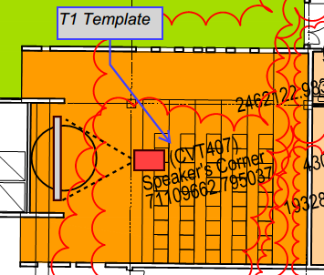

|  |  |  |
| --- | --- | --- |
| Department | Comments | Actioned |
|  |  |  |
|  |  |  |
|  |  |  |
|  |  |  |
|  |  |  |

**Room 453 & 457**

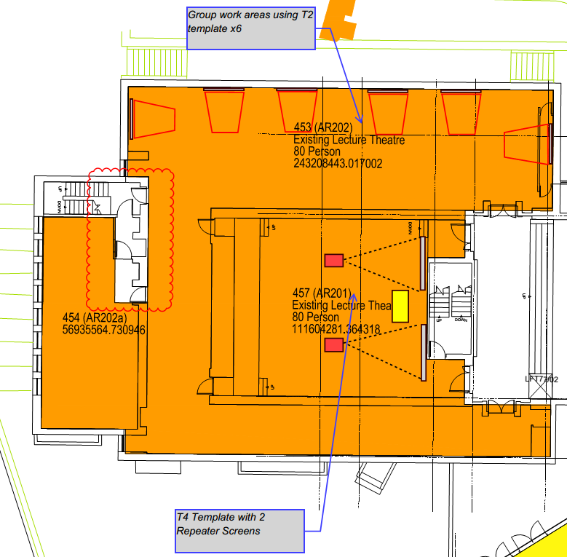

|  |  |  |
| --- | --- | --- |
| Department | Comments | Actioned |
|  |  |  |
|  |  |  |
|  |  |  |
|  |  |  |
|  |  |  |

**Rooms 461, 463, 464, 466 & 467**

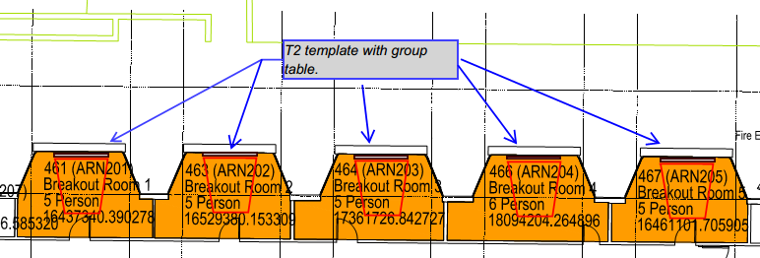

|  |  |  |
| --- | --- | --- |
| Department | Comments | Actioned |
|  |  |  |
|  |  |  |
|  |  |  |
|  |  |  |
|  |  |  |

**Room 462**

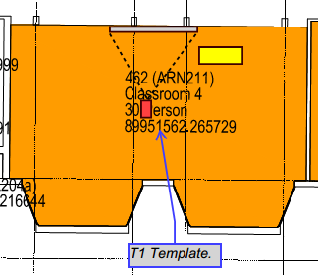

|  |  |  |
| --- | --- | --- |
| Department | Comments | Actioned |
|  |  |  |
|  |  |  |
|  |  |  |
|  |  |  |
|  |  |  |

**Room 465**

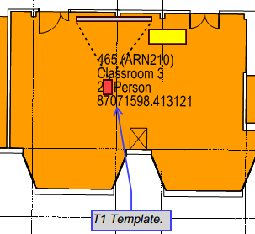

|  |  |  |
| --- | --- | --- |
| Department | Comments | Actioned |
|  |  |  |
|  |  |  |
|  |  |  |
|  |  |  |
|  |  |  |

**Room 468**

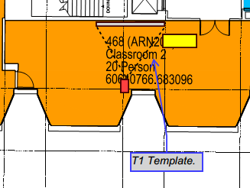

|  |  |  |
| --- | --- | --- |
| Department | Comments | Actioned |
|  |  |  |
|  |  |  |
|  |  |  |
|  |  |  |
|  |  |  |

**5th Floor**

**Room 551 inc a&b**

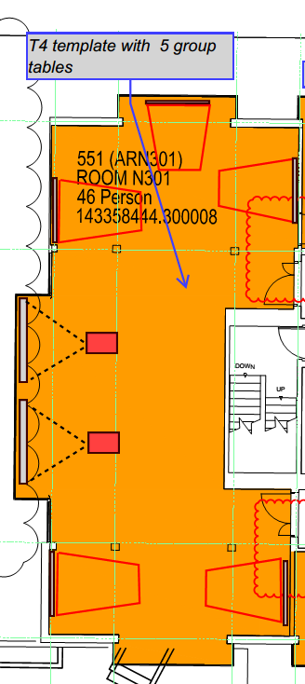

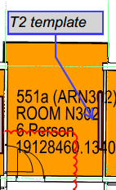 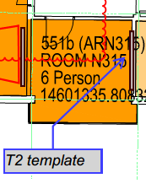

|  |  |  |
| --- | --- | --- |
| Department | Comments | Actioned |
|  |  |  |
|  |  |  |
|  |  |  |
|  |  |  |
|  |  |  |

**Room 552**

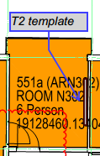

|  |  |  |
| --- | --- | --- |
| Department | Comments | Actioned |
|  |  |  |
|  |  |  |
|  |  |  |
|  |  |  |
|  |  |  |

**Room 553**

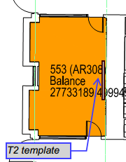

|  |  |  |
| --- | --- | --- |
| Department | Comments | Actioned |
|  |  |  |
|  |  |  |
|  |  |  |
|  |  |  |
|  |  |  |

**Room 555**

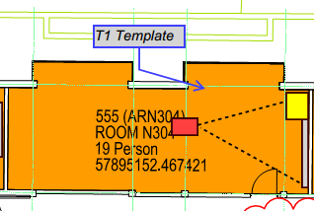

|  |  |  |
| --- | --- | --- |
| Department | Comments | Actioned |
|  |  |  |
|  |  |  |
|  |  |  |
|  |  |  |
|  |  |  |

**Room 556**

**TBC**

|  |  |  |
| --- | --- | --- |
| Department | Comments | Actioned |
|  |  |  |
|  |  |  |
|  |  |  |
|  |  |  |
|  |  |  |

**Room 557**

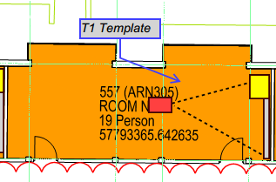

|  |  |  |
| --- | --- | --- |
| Department | Comments | Actioned |
|  |  |  |
|  |  |  |
|  |  |  |
|  |  |  |
|  |  |  |

**Room 558**

**TBC**

|  |  |  |
| --- | --- | --- |
| Department | Comments | Actioned |
|  |  |  |
|  |  |  |
|  |  |  |
|  |  |  |
|  |  |  |

**Room 559**

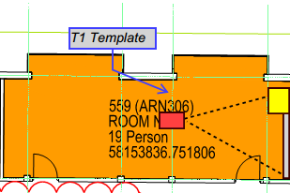

|  |  |  |
| --- | --- | --- |
| Department | Comments | Actioned |
|  |  |  |
|  |  |  |
|  |  |  |
|  |  |  |
|  |  |  |

**Room 562**

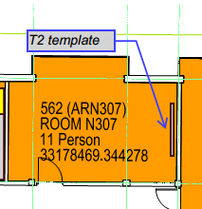

|  |  |  |
| --- | --- | --- |
| Department | Comments | Actioned |
|  |  |  |
|  |  |  |
|  |  |  |
|  |  |  |
|  |  |  |

**Room 564**

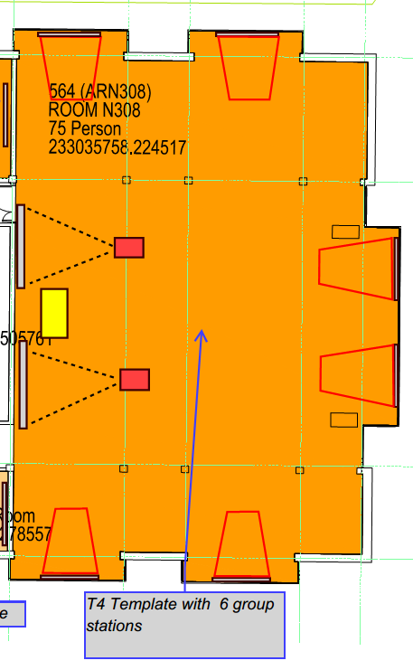

|  |  |  |
| --- | --- | --- |
| Department | Comments | Actioned |
|  |  |  |
|  |  |  |
|  |  |  |
|  |  |  |
|  |  |  |

**Room 565, 566 & 568**

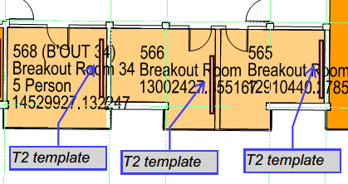

|  |  |  |
| --- | --- | --- |
| Department | Comments | Actioned |
|  |  |  |
|  |  |  |
|  |  |  |
|  |  |  |
|  |  |  |

**Room 570**

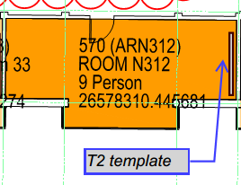

|  |  |  |
| --- | --- | --- |
| Department | Comments | Actioned |
|  |  |  |
|  |  |  |
|  |  |  |
|  |  |  |
|  |  |  |

**Room 572**

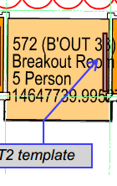

|  |  |  |
| --- | --- | --- |
| Department | Comments | Actioned |
|  |  |  |
|  |  |  |
|  |  |  |
|  |  |  |
|  |  |  |

**Room 574**

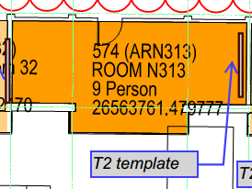

|  |  |  |
| --- | --- | --- |
| Department | Comments | Actioned |
|  |  |  |
|  |  |  |
|  |  |  |
|  |  |  |
|  |  |  |

**Room 575**

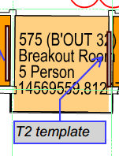

|  |  |  |
| --- | --- | --- |
| Department | Comments | Actioned |
|  |  |  |
|  |  |  |
|  |  |  |
|  |  |  |
|  |  |  |

**Room 577**

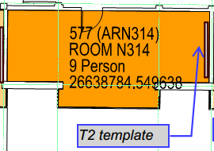

|  |  |  |
| --- | --- | --- |
| Department | Comments | Actioned |
|  |  |  |
|  |  |  |
|  |  |  |
|  |  |  |
|  |  |  |

**Room 578**

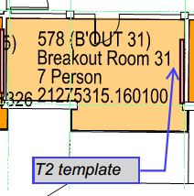

|  |  |  |
| --- | --- | --- |
| Department | Comments | Actioned |
|  |  |  |
|  |  |  |
|  |  |  |
|  |  |  |
|  |  |  |

**Room 505**

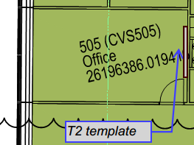

|  |  |  |
| --- | --- | --- |
| Department | Comments | Actioned |
|  |  |  |
|  |  |  |
|  |  |  |
|  |  |  |
|  |  |  |

**6th Floor**

**Room 651**

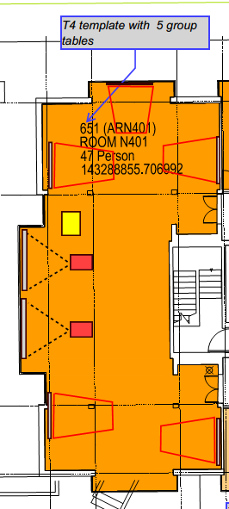

|  |  |  |
| --- | --- | --- |
| Department | Comments | Actioned |
|  |  |  |
|  |  |  |
|  |  |  |
|  |  |  |
|  |  |  |

**Room 652**

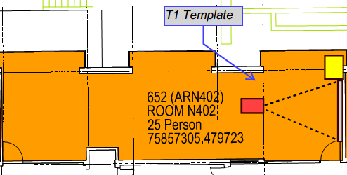

|  |  |  |
| --- | --- | --- |
| Department | Comments | Actioned |
|  |  |  |
|  |  |  |
|  |  |  |
|  |  |  |
|  |  |  |

**Room 653**

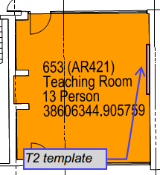

|  |  |  |
| --- | --- | --- |
| Department | Comments | Actioned |
|  |  |  |
|  |  |  |
|  |  |  |
|  |  |  |
|  |  |  |

**Room 655**

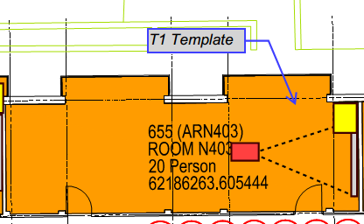

|  |  |  |
| --- | --- | --- |
| Department | Comments | Actioned |
|  |  |  |
|  |  |  |
|  |  |  |
|  |  |  |
|  |  |  |

**Room 656**

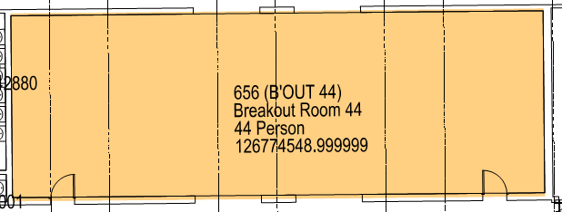

|  |  |  |
| --- | --- | --- |
| Department | Comments | Actioned |
|  |  |  |
|  |  |  |
|  |  |  |
|  |  |  |
|  |  |  |

**Room 657**

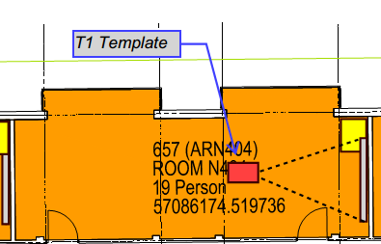

|  |  |  |
| --- | --- | --- |
| Department | Comments | Actioned |
|  |  |  |
|  |  |  |
|  |  |  |
|  |  |  |
|  |  |  |

**Room 661**

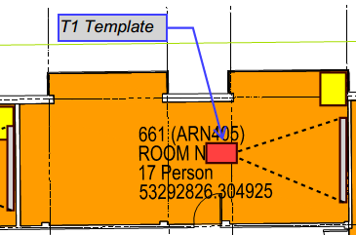

|  |  |  |
| --- | --- | --- |
| Department | Comments | Actioned |
|  |  |  |
|  |  |  |
|  |  |  |
|  |  |  |
|  |  |  |

**Room 663**

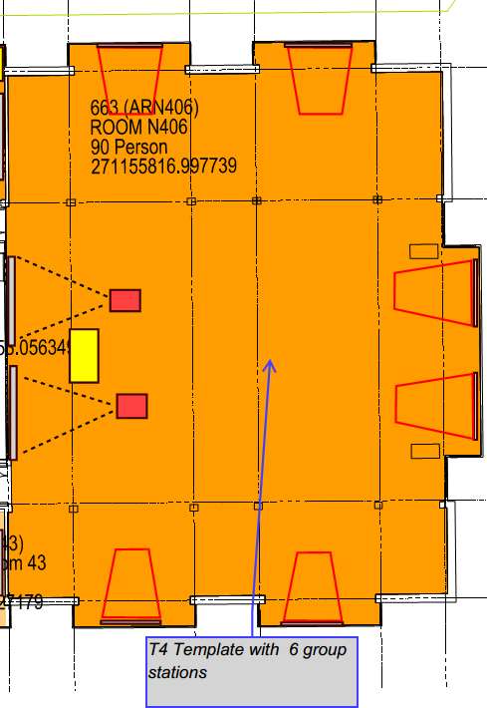

|  |  |  |
| --- | --- | --- |
| Department | Comments | Actioned |
|  |  |  |
|  |  |  |
|  |  |  |
|  |  |  |
|  |  |  |

**Room 664**

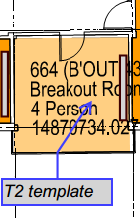

|  |  |  |
| --- | --- | --- |
| Department | Comments | Actioned |
|  |  |  |
|  |  |  |
|  |  |  |
|  |  |  |
|  |  |  |

**Room 667**

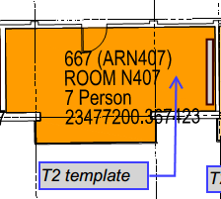

|  |  |  |
| --- | --- | --- |
| Department | Comments | Actioned |
|  |  |  |
|  |  |  |
|  |  |  |
|  |  |  |
|  |  |  |

**Room 669**

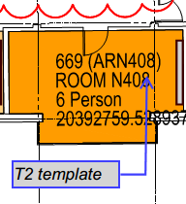

|  |  |  |
| --- | --- | --- |
| Department | Comments | Actioned |
|  |  |  |
|  |  |  |
|  |  |  |
|  |  |  |
|  |  |  |

**Room 670**

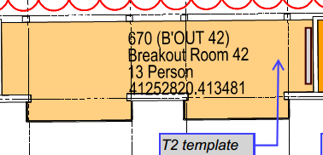

|  |  |  |
| --- | --- | --- |
| Department | Comments | Actioned |
|  |  |  |
|  |  |  |
|  |  |  |
|  |  |  |
|  |  |  |

**Room 671, 672 & 673**

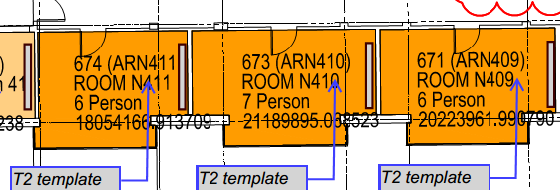

|  |  |  |
| --- | --- | --- |
| Department | Comments | Actioned |
|  |  |  |
|  |  |  |
|  |  |  |
|  |  |  |
|  |  |  |

**Room 675**

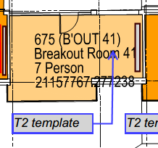

|  |  |  |
| --- | --- | --- |
| Department | Comments | Actioned |
|  |  |  |
|  |  |  |
|  |  |  |
|  |  |  |
|  |  |  |

**Room 605**

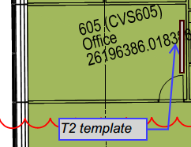

|  |  |  |
| --- | --- | --- |
| Department | Comments | Actioned |
|  |  |  |
|  |  |  |
|  |  |  |
|  |  |  |
|  |  |  |

**Room 705**

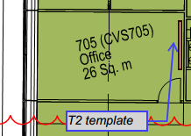

|  |  |  |
| --- | --- | --- |
| Department | Comments | Actioned |
|  |  |  |
|  |  |  |
|  |  |  |
|  |  |  |
|  |  |  |

**Room 805**

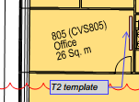

|  |  |  |
| --- | --- | --- |
| Department | Comments | Actioned |
|  |  |  |
|  |  |  |
|  |  |  |
|  |  |  |
|  |  |  |