**Strathclyde Doctoral School - Briefing**

**Purpose**

This briefing provides an overview of the mission, objectives, and governance structure of the newly-established *Strathclyde Doctoral School*, which will officially launch in September 2018.

**Background**

In autumn 2017, the Executive Team requested, and subsequently endorsed, proposals for a University-wide Strathclyde Doctoral School (SDS) that would ensure a prominent and cohesive provision for postgraduate research students at Strathclyde. The overarching structure aims to provide escalated and unified PGR profile and support, as aligned with the University’s strategic ambitions of delivering outstanding student experience, internationally leading research, and world-leading innovation and impact.

The University of Strathclyde is firmly positioned among the leading research-intensive universities in the UK and our research activity is of central importance to our institutional strategy and ambitions. Aligned with this, Strathclyde postgraduate researchers (PGRs) are key contributors to our research delivery. The Strathclyde PGR community has seen strong growth over recent years, which can be attributed to the collaborative approach adopted amongst individual academics, Faculties/Departments/Schools, and RKES support colleagues, underpinned by further central provision. The development of a distinctive, innovative, and robust research environment will enable and support the further growth required in line with 2020 targets, whilst enhancing the University’s position amongst our national and international peers.

Developing a cohesive approach to PGR activities will enable the development of a more interconnected community of PG researchers creating an overarching research environment where interdisciplinary opportunities are encouraged and promoted. By supporting and streamlining existing PGR processes, and drawing focus to student progression and completion rates, the overall quality of experience of PGRs can be enriched. This enhanced experience and sector leading research environment will draw together strong marketing messages to feed into PGR recruitment activities.

The first meeting of the *Strathclyde Doctoral School Executive Board*, chaired by Deputy Associate Principal (R&KE), Professor Billy Kerr, took place in early June. At this meeting, the SDS Executive Board agreed the governance structure, and the overarching mission, remit, and objectives for the Strathclyde Doctoral School. The *SDS Management Board* has also been established and will meet for a briefing and information session in late June.

**Mission**

The Strathclyde Doctoral School drives both strategic and operational developments that enhance the postgraduate researcher experience. Our mission is to create an environment where our research students can flourish. Providing opportunities for interdisciplinary engagement, we promote a sense of PGR community. By delivering a framework of support, we encourage and enable appropriate progress monitoring and timely completions. Our outstanding training and development opportunities prepare our students to become future research and business leaders. We recognise, celebrate, and value the contribution our postgraduate cohorts make to Strathclyde’s research delivery and overall international standing.

**Objectives**

The vision for Strathclyde Doctoral School is that collaborative and partnership working amongst Faculities and Professional Services will deliver enhanced provision, profile, and student experience without duplicating current local activities.

There are a range of objectives that must be delivered in order that the Strathclyde Doctoral School meets its ambitions. These objectives can be grouped under the broad headings of *Student Experience*, *Research Environment*, and *PGR Marketing, Promotion, and Readiness*.

***Student Experience***

The Strathclyde Doctoral School will:

1. create a comprehensive approach to the professional development of postgraduates, in particular, by enhancing PGR skills sets and experience through our sector-leading Researcher Development Programme (RDP), and clear governance and certification of professional development offerings to enhance our PGR graduates’ employability;
2. enhance the support framework that ensure PGRs progress and complete on time by coordinating inputs to and reporting on student progress, completion rates, and overall quality of supervision and related provisions;
3. support PGR supervisors (and related staff) in relation to new and existing studentships, including PGR student administration and central finance/leverage support, and support the resolution of non-academic issues associated with studentships; and
4. be the voice of PGRs at Strathclyde.

***Research Environment***

The Strathclyde Doctoral School will:

1. create an inclusive overarching research environment where interdisciplinary, societal engagement, and impact opportunities are encouraged and promoted, facilitating enhanced collaboration and research community connectivity;
2. enhance our research culture and PGR community by showcasing the research activities and outputs of PGRs, and their value to business and society; and
3. facilitate communication and coordination between existing institutional CDTs and related centres, and establish and coordinate agile responses to sectoral priorities, research environment changes, and funder requests; this capability and approach will also be employed as part of both internal and external horizon scanning.

***PGR Marketing, Promotion, and Readiness***

The Strathclyde Doctoral School will:

1. be a branded profile with a strong web presence to assist marketing endeavours;
2. ensure the presentation of a vibrant, student-centred research environment at Strathclyde that reinforces students’ sense of belonging within the Strathclyde community; and
3. facilitate the preparation of PGT students for transition to the PGR domain by creating a talent pipeline from our PGT courses, for example, by targeting existing high-quality PGT students by inclusion within PGR conference and workshop activities, and providing access to level-relevant RDP courses, including those designed to introduce the concept of and approach to research studies.

**Governance**

The aim of the Strathclyde Doctoral School is to provide a positive profile and comprehensive support environment for postgraduate researchers without being intrusive to research management, delivery, or practices which work well. The governance structure below has been agreed, with the SDS Executive Board, ultimately, reporting to the University Executive Team.

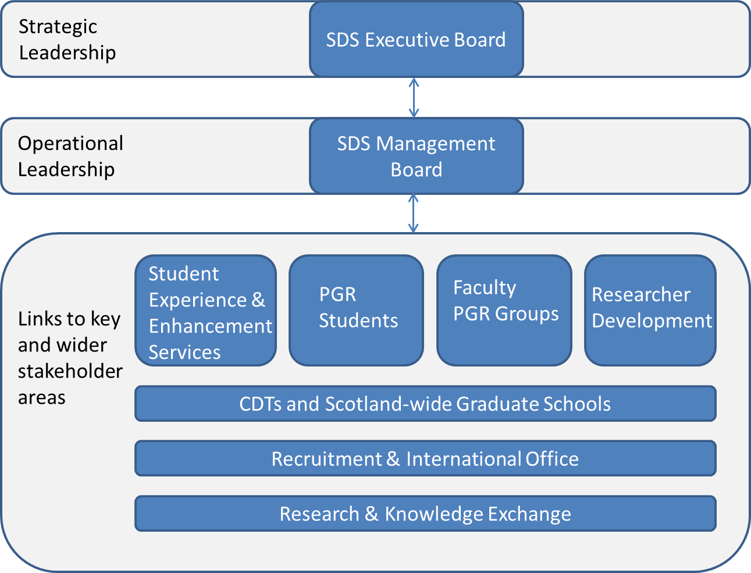

***SDS Executive Board***

* Deputy Associate Principal, R&KE
* Executive Deans of each Faculty
* SDS Director
* SDS Manager
* Acting Director of Education Enhancement

Consulting members, include staff from Strategy & Policy, Marketing & Development, Recruitment & International Office, Finance, and Faculty Support, as well as student representatives.

***SDS Management Board***

* Deputy Associate Principal, R&KE
* SDS Director
* SDS Manager
* Vice-Deans of each Faculty (Research or Academic, where appropriate)
* PG Cert. Researcher Professional Development (RDP) lead
* SEES representative

**Plans and progress**

Immediate and short-term action plans have been developed, which detail key deliverables aligned to the stated objectives.

***Phase 1 – June 2018 to January 2019***

Efforts towards establishing an appropriate web profile for the SDS is underway. The overall structure has been agreed and work will be undertaken with key stakeholders over the coming months to launch the new SDS webpages at the start of the academic year (early September).

Phase 1 will drive a review period where teams of colleagues, under the auspices of the SDS, will work in partnership to understand and review components of the PGR lifecycle. This includes current marketing and recruitment activities and strategies, the PGR Regulations and Code of Practice, and PGR lifecycle administrative processes. These are all areas that sit across Faculties and Professional Services, and it is intended that colleagues work together to establish effective and consistent practice.

The PGR student voice is a key part of the SDS and we will be seeking to support the establishment of a Doctoral Researchers’ Group, akin to the Researchers’ Group comprising ECR staff. We will be entering the Postgraduate Student Experience Survey (PRES) in 2019, which will be a further mechanism to draw in PGR views of their experience at Strathclyde.

***Phase 2 – February – September 2019***

In Phase 2 we will focus on establishing the appropriate direction for developments of the key areas reviewed and initiated in Phase 1. We will work to optimise the SDS web presence and this will form part of wider discussions around PGR marketing activities. It is anticipated that a strategy group will be convened to agree an appropriate institution strategy for PGR promotion and marketing.

Creating an overarching PGR ‘research community’ *via* SDS, through interdisciplinary activities and events, will be a further focus of Phase 2. Working with, and learning from, groups such as the CDTs (and similar centres) will enable sharing of good practice. From this we will surface and showcase research activities and outputs generated by our PGRs, which will subsequently feed into promotion and marketing messages.

**Next Step**

A series of communications relating to the Strathclyde Doctoral School will be released to staff and students over the coming months and into the 2018/19 academic session.