Accessible documents for Physics dept.

# Intro and aims

Since today’s session is scheduled to run for only an hour, its scope will of necessity be quite limited. So what I thought it would be best to do with the time available is to try to show you some ways that you can improve the accessibility of your existing course materials right now and with minimal fuss. We’ll do this by looking at potential areas of difficulty in the previous documents the department has created. I’m also going to signpost you to some other resources towards the end of the session which can help you to further improve the accessibility of your documents, but some of these might take a bit more of a time commitment on your part. Probably the single best thing you can do to supplement today’s session is to sign up to our Creating Accessible Documents training session, where you will meet my colleague Carol Howieson, who is our expert in this field. This training is conducted in a computer lab to enable you to gain hands-on experience with the necessary procedures for improving accessibility in Word, PDF and PowerPoint. You may also want to consider attending the Working with Visually Impaired Students workshop, which is a companion session to the accessible documents workshop.

Unfortunately, it is outwith the scope of today’s meeting, and outwith my expertise, to talk about accessibility in LaTex. Being more of a specialised tool, LaTeX doesn’t actually feature in our training sessions either at the moment. However, the EquatIO software that I will discuss later will be of great benefit in helping you create accessible maths in LaTeX. At the end of the session I will also point you to several resources that might be worth exploring with regards to creating accessible maths more generally. Our service would also be happy to work together with your department in future to improve knowledge and practice in this area.

# Visually impaired students

When Gabrielle first got in touch with me about this session she specifically asked about making documents accessible to Read & Write GOLD software. This software is generally used by students with specific learning difficulties such as dyslexia, but I think it will be important throughout this discussion to keep the needs of visually impaired students in mind too, as they are the cohort most likely to be most strongly affected by a lack of print accessibility. Even if you don’t currently have any visually impaired students in your department it would be best to be anticipatory in your document design, rather than being left fire-fighting when a visually impaired student does sign up.

Visually Impaired students would be more likely to use screen reading software, rather than Read & Write GOLD, but there will be some students who use both, and the steps to make documents accessible for both types of application are the same. There is also a great deal of overlap between the print accessibility needs of these two cohorts of students.

# Some minor design issues with the Plasma Physics lecture slides

Gabrielle and Nigel kindly sent over a few documents that had been used on your courses last year so that Carol and I could identify any problematic design issues. I’ve just chosen one document to refer to today: Plasma Physics (lecture 12). This document was no worse or better than the others and was chosen simply because it was first attachment in the email I received. It’s a PDF that seems to have been created from a PowerPoint slideshow. The first minor issue to note is that centred text at the beginning of the document is not particularly accessible because when a visually impaired student is using screen magnification, they will be zooming in on the document to a very high degree and it is much more useful for the text to be visible in the top left-hand corner of the page, otherwise the student may skip a whole section of text thinking that they are looking at a blank area. Try to avoid centring as it’s probably only ever being used for aesthetic purposes. (While we are on this subject, it also best to use at least a minimum font size of 12 and to use sans serif fonts.)

The next thing to note is that the date and the lecturer’s name appear on every page of the document. The page numbering that has been included in the footer is usually quite helpful to students, but this additional information will be read out repeatedly by screen readers and by Read & Write GOLD, and this can become very disruptive to the reading/listening experience, even more so since some users of Read & Write GOLD will actually prefer to create mp3s of the document rather than listening and reading along. A simple solution here would be to put this information at the start of the document or section: ‘slides created on the… all slides created by…’. Or even add it to the document properties instead.

# Making images accessible – descriptions or alt-text

The first major issue to discuss is that the document relies heavily on images. The use of images is particularly problematic if a visually impaired student is accessing your materials. In the vast majority of cases you will have chosen to use an image because it supplements and supports the meaning of the text it accompanies, and therefore visually impaired students will be placed at a disadvantage if the image is not described.

Certain types of image are also problematic even for sighted users of Read and Write GOLD, because images often contain text, and the software will simply skip over the entire image meaning that these students are also significantly disadvantaged.

To avoid these issues images must be described, and description of images can be handled in two ways: by adding a description of the image into the main text; or by adding alternative text to the image. This alt-text will not be visible to anyone reading the document manually, but will be picked up by screen readers and by the latest version of Read & Write GOLD.

It might be helpful to look at a couple of examples, of differing complexity, at this stage. For example, we could look at this image of the sun from and early slide:



When working with images the best starting point is to ask: what information would be lost if the pictures were redacted? It may be the case that an image like this isn’t conveying a huge amount of extra information so for example, here we could just add the following statement into the body of the text: plasma reactions cause the sun to appear as a large ball of fire with flames and vapours escaping its surface. If you are not keen on building this information into the surface level of your document, then alternative text can be used.

# Adding alternative text to an image

The instructions below – taken from the Making Accessible Documents and PDFs with Word 2010 document, also provided - describe adding alternative text to an image. A similar process should be followed when inserting other objects such as Clip Art, SmartArt diagrams and Charts.

1. Insert the image into the document.

2. Select the **Format** tab on the Word ribbon.

3. Select the **Dialog Box Launcher** located in the **Picture Styles** group.

4. Select the **Alt Text** pane on the **Format Picture** dialog box.

5. Enter a brief description of the purpose of the image into the **Description** field.

6. Select the **Close** button.

In more modern versions of Word it is likely that the Alt Text button will appear immediately upon you selecting the Format tab in the word Ribbon, meaning that you can skip stage 3.

# Complex images

As the images you employ become more complex, naturally your descriptions need to be more involved. So let’s take another image from later in the same lecture:

When Plasma is self-heated by fusion alpha particles, Deuterium, which consists of 1 red and 1 green, and Tritium, which consists of 1 red and 3 greens, react within the sun creating an output of Helium, which consists of 2 reds and 2 greens, as well as creating excess energy and a single green neutron.

Here there is a vast amount of content that would be inaccessible to visually impaired students. A great deal of this content would also be inaccessible to students using Read and Write GOLD, because the majority of the information contained in the image is text-based.

Your description of the image would need to be thought through very carefully to ensure that no content is being missed by these students. The best starting point for your description is to think: what would I say during the lecture to explain this image? As I lack the technical ability to describe this image in a meaningful way, I’ve just created the following (abstract) attempt at a description: When Plasma is self-heated by fusion alpha particles, Deuterium, which consists of 1 red and 1 green, and Tritium, which consists of 1 red and 3 greens, react within the sun creating an output of Helium, which consists of 2 reds and 2 greens, as well as creating excess energy and a single green neutron. Next we will look at adding this description to a hidden slide.

# Hidden slides

If you are working directly in PowerPoint then it may be best if you include descriptions on hidden slides which can then be read by screen readers but which will not appear in your lecture presentations. The Hide Slide option can be turned on and off individually for each slide in your presentation by right clicking on the small version of the slide in the navigation pane, and then selecting Hide Slide from the pop-up menu, as can be seen in the following image:

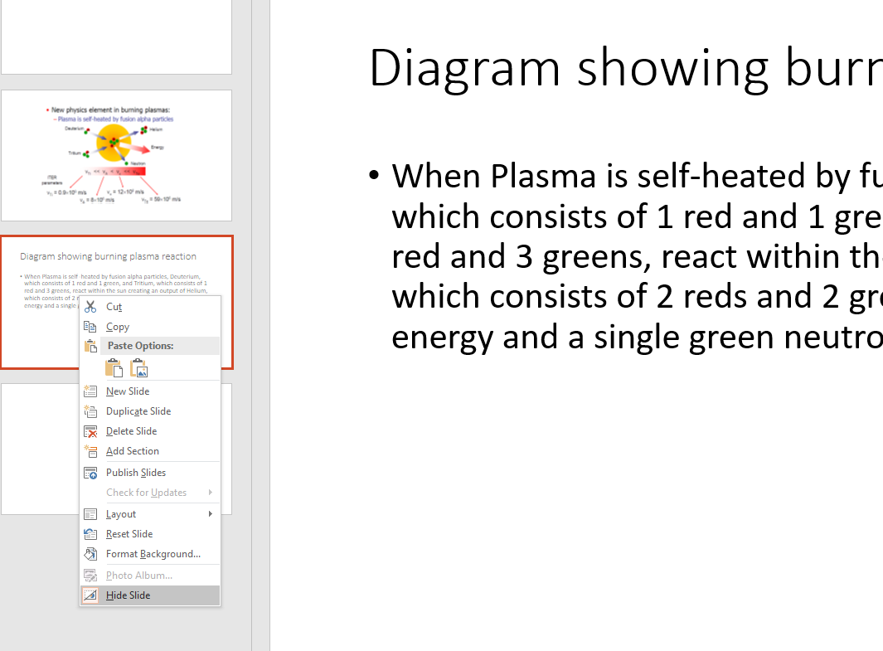

# Making equations accessible with EquatIO

The next problematic feature of the burning plasma image is that it also contains mathematical symbols. As the plasma lecture goes on, more and more equations appear in the presentation. It will be essential for any equations to be accessible to screen readers for visually impaired students, but it will also be of great benefit to dyslexic students to hear equations being read aloud, as it can be difficult for these students to correctly interpret large strings of symbols. For this reason we want equations to be accessible to Read & Write GOLD too. This would allow your dyslexic students to select a slow reading speed and to listen back over equations several times to try to absorb their content.

I was trying this week to find the simplest solution for your department to change how you approach equations, and it seems like the EquatIO app is going to be the best quick fix. It is not absolutely perfect, as we will see later, but the good news is that it will even work with images like the burning plasma diagram, where the equations are embedded within the image. There is also a LaTeX editor built into the EquatIO app.

EquatIO has been created by Text-Help, the makers of Read & Write GOLD, and it they claim it has been designed to work seamlessly with Read & Write. This software is also free to download and the premium version is free for teachers and educators (as is Read & Write GOLD). In anticipation of today’s session, I downloaded and tested the software, and as long as students are using the most recent version of Read and Write, it does recognise and clearly read the equations. I must point out that due to this being our busiest time of year, my testing has been limited, but so far it looks like a very sophisticated solution to a number of problems you might face with accessibility.

Academics and students can use EquatIO to access previously inaccessible maths on screen, and to create accessible equations using various input methods such as speech and drawing. It has a toolbar that sits in the web browser, or you can just have the program sitting at the bottom of your screen if you are working with offline documents. The screenshot reader function makes it easy to grab any inaccessible equation and have it read aloud while also having it converted into an accessible maths format. Once converted, different versions of the equation – including MathML and LaTeX versions - can be copied and edited in the EquatIO editor before being inserted into your document. As the following video shows, it even works with handwritten equations and with equations appearing on screen in videos.

**The following link will allow you to view a video of the EquatIO screenshot reader in action:** <https://www.youtube.com/watch?v=MQ5pNzrgbBw> (Apologies for the poor sound quality in this presentation.)

You can probably see from this short video how your department could use the screenshot reader to fix any inaccessible documents you are currently teaching with, and if you used the software to create equations in future documents then you could move towards total accessibility. The software could also be recommended to students who may be dealing with any inaccessible content created outwith the university.

(You can find lots of useful information and tutorial videos on EquatIO if you search for it in your browser or on YouTube.)

# Using the EquatIO screenshot reader

I will now demonstrate this app and show you how you could use it to quickly improve the accessibility of your equations. To do this we will return to the complex slide about burning plasmas. This image contained several embedded equations which would normally be problematic for screen readers and for Read & Write GOLD. But all we need to do to access these equations is:

1. Open EquatIO

2. Select the **Screenshot Reader** function.

3. Click and drag your pointer over an equation. EquatIO will now read the equation aloud.

4. Select the **Further Options menu** (indicated by three dots: **…**).

5. Copy to whichever format is desired or chose to edit the equation in the app.

6. Paste the equation into your destination document/slideshow using the **Insert Math** button.

Once you have extracted accessible version of this mathematical content it can be added to alt-text or to a hidden slide, as shown above.

# What can be done if Read & Write GOLD doesn’t cope with a particular symbol

One issue that I have identified in testing is that Read & Write GOLD seems to want to read the velocity symbol as the Roman numeral for 5, even though EquatIO itself doesn’t have this problem. This is obviously a significant issue in your subject.

I have sent a request to Text-Help for clarification on this issue but so far have received no response unfortunately. Read & Write GOLD does allow users to add new pronunciations when problems like this arise so I anticipate there will be a workaround for the issue that I can send on to you. Since the apps are made by the same team I hope the fix should be a simple one.

I have also come up with my own workaround for the moment which is to edit the alt-text associated with the problematic equation. This can be done easily by right clicking on the equation you have pasted into your document and selecting **Edit Alt Text**, as shown in the image below.

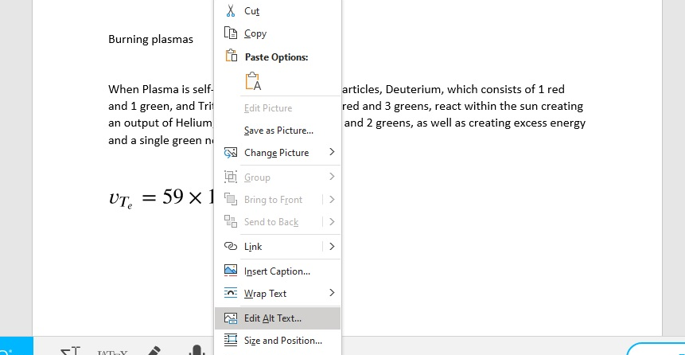

# Extra maths creation resources

In this section I have included some extra resources relating to the creation of accessible maths, as this is probably the most challenging area for your department currently.

MathML

<http://www.w3.org/Math/>

Mathematical Markup Language (MathML) is a mathematical markup language, an application of XML for describing mathematical notations and capturing both its structure and content. It aims at integrating mathematical formulae into World Wide Web pages and other documents. It is part of HTML5 and an ISO standard ISO/IEC DIS 40314 since 2015.

## MathPlayer

<https://www.dessci.com/en/products/mathplayer/> <https://www.dessci.com/en/products/mathplayer/versionhistory.htm>

Design Science MathPlayer™ is a universal math reader that now enables math to be spoken in assistive technology products. MathPlayer continues to have the most advanced support for MathML of any renderer available, including support for MathML 3 features such as line-breaking, indentation and elementary math, and supports both visual rendering and speech in Internet Explorer (requires Enterprise Mode in IE11 which can be downloaded using the following link: <https://www.dessci.com/en/products/mathplayer/tech/default.htm#Enterprise_mode> )

MathPlayer is based on MathML technology and we make it available for free in order to foster the adoption of MathML in the math, science, and education communities. MathPlayer can be downloaded using the following link: <https://www.dessci.com/en/products/mathplayer/download.htm>

MathJAX

<https://www.mathjax.org/#a11y>

The core of the MathJax project is the development of its state-of-the-art, open source, JavaScript platform for display of mathematics. Our key design goals are:

High-quality display of mathematics notation in all browsers.

No special browser setup required.

Support for LaTeX, MathML, and other equation markup directly in the HTML source.

An extensible, modular design with a rich API for easy integration into web applications.

Support for accessibility, copy and paste, and other rich functionality.

Interoperability with other applications and math-aware search.

Support for equation conversion outside a browser (e.g., preprocessing on a server).

The following video demonstrates MathJax: <https://www.youtube.com/watch?v=6GSgTjorewQ&feature=youtu.be>

# Concluding remarks

I have sent some additional resources to Gabrielle which might help to supplement our session today. One of these is the booklet from the Accessible Documents training which will teach anyone who is new to this area important accessibility techniques like using styles and tables in Word, and how to safely convert Word files to PDF to ensure accessibility features are retained.

Please let us know if you have any questions relating to the issues discussed today, and thanks for taking the time to consider accessibility for your students.