**A Step-by-step Guide to Costing KE Activities - Faculty of Science, June 2020**

**1. Is it knowledge exchange or research?**

The decision on whether an activity is research or knowledge exchange is determined in accord with the Frascati definition of research: <https://en.wikipedia.org/wiki/Frascati_Manual>. However, a good working rule is that *research* generates knowledge whilst *knowledge exchange* utilises existing knowledge. Excluding industry-funded research, other types of commercial or public engagements that are classified as knowledge exchange activities at Strathclyde include consultancy, continuous professional development (CPD), conferences, communicating with the public, access to equipment and facilities and impact accelerator activities. Exceptions include industrially funded PhD students (which are classified as teaching) and Knowledge Transfer Partnerships (which curiously are classified by the University as research).

**2 What should I use for costing KE activities?**

The Knowledge Exchange System (KES) is the costing tool.

Although KES and the Project Costing Module of FMS seem to have similar functions, RKES view them quite differently. This is partly because the costing of research is based on full economic costing (FEC), a model which was implemented nationally from 2005. Costs are derived from the Time Allocation Exercise (TAS) and thence Transparent Approach to Costing (TRAC). By contrast, there is no national or local model for costing KE activity. For that reason, RKES consider PCM to be inappropriate for costing knowledge exchange activities, choosing instead to direct knowledge exchange costings to KES.

KES is easy and straightforward to use. Strictly speaking, KES does not actively cost (for example there are no calculations of staff costs as in PCM) and it depends on the cost information that you, as an individual, puts into it. Accordingly, it is possible to misrepresent costs in KES unless you properly establish the costs of individual elements of the KE activity. KES is, however, an excellent single point for identifying, collating and recording all elements of your KE provisions*.* KES is also the mechanism by which KE activities are approved by your HoD and RKES.This document is designed to help you avoid common pitfalls in costing KE, provides guidance on what prices you should be charging, and how to use KES efficiently.

**3. When should I use the KES tool?**

The KES tool should be used after you have made a detailed plan of work for the activity you are carrying out but before you say anything to the customer about price! The plan of work should identify every person who will need to be involved in carrying out the activity so their time can be costed. It should also identify all direct costs such as consumables, access fees for equipment/facilities, subcontract work, travel subsistence costs etc. If the activity is a commercial project you are advised, based on your initial discussions, to make your planned work programme as ambitious as possible. This is because commercial partners will typically employ negotiators whose main role is to reduce the price of any proposed contract. It is generally preferable to agree a reduction by reducing the project scope rather than simply lowering the overall price. **Don’t make on-the-hoof costing promises to companies the first time you meet them.**  Use the costing categories in KES to help shape your thoughts on what to include in your costing. You need to consider all aspects of the project and estimate costs. Always take time to reflect on the totality of what is involved and put together a complete work plan and apply the costing tool to it BEFORE entering into discussions about prices! **Remember that the price we charge for our services and expertise should represent the value of these services, not simply the cost of provision.** If a company needs the work done they will likely find a way of paying for it and how they do that should not be your concern.

**4. Where can I find the KES tool?**

You’ll find it on Pegasus by clicking on the Research and KE tab.

**5. How do I use KES to help me with my costing?**

This costing support tool is easy to use and is relatively self-explanatory, working mostly from drop-down menus. There are some important elements to consider, and these are outlined in the instructions below.

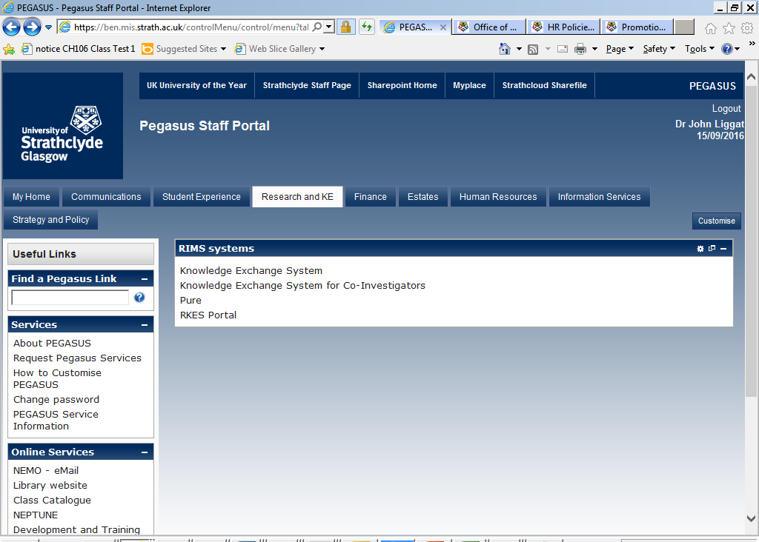

This is what you will find under the Research and KE tab on Pegasus.

Click on *Knowledge Exchange System*, then from there *Create a new Knowledge Exchange Project*

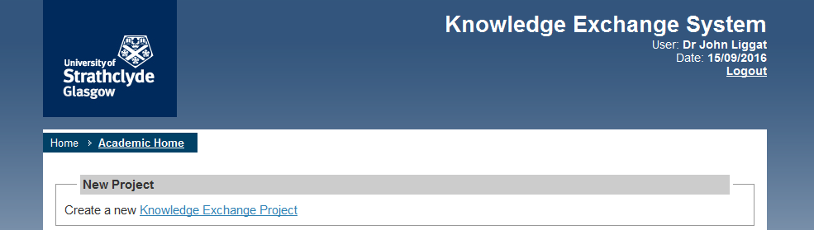

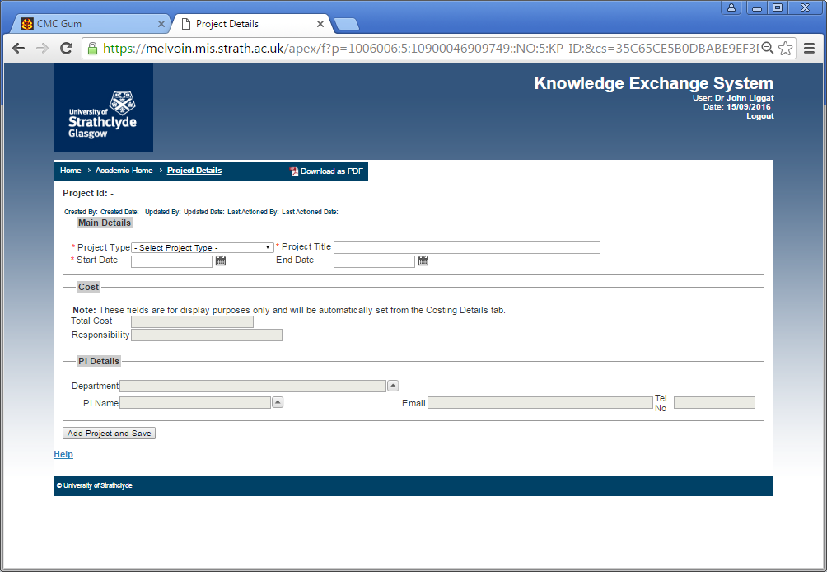

This is the front page of your costing. Fill out the details of the project and PI. There are several project types to choose from: C*onference/seminar hosting*, *publications*, *services/consultancy*, *training and short courses* (CPD), *facilities and equipment services*, *expert witness*, *Erasmus+,* and knowledge *exchange* (which, despite its generic-sounding name, covers public engagement costs). Once you’ve completed the details, click *Update and Save*, and then work through the other tabs. They are mostly self-explanatory.

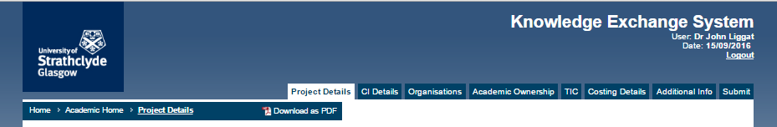

However, the *Costing Details* tab needs some explanation as this is the most important element of the costing.

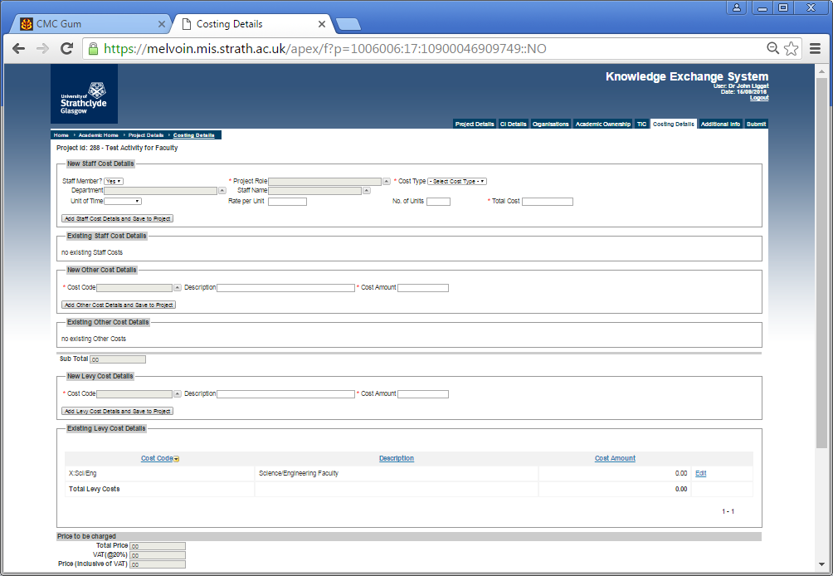

If you want to cost your time, or that of a colleague, research assistant etc., use the *New Staff Costing Details* section. Note that unlike PCM, the form does not automatically calculate the cost based on staff grade. RKES provide minimum recommended day rates for use when costing KE activity. These are calculated on the basis of the full economic cost of research activity for each of the categories of staff and are provided as a guide only when costing KE activity. The figures include the banded salary rate + indirect costs + estates costs + infrastructure technician costs (where applicable) per annum, divided by 220 working days per annum.  However, the use of the RKES rates can be problematic as the KES costing tool is such the Faculty levy is unavoidably also added, which leads to an element of double surcharging. However, the Faculty Recommended Day Rates in the table below are based on salary-related costs only and avoid this problem.

Note that the figures should be used as a minimum starting guide when estimating a contract price and need to be more than doubled for consultancy work (see below).

|  |  |
| --- | --- |
| Staff Category | Faculty Recommended  Staff Day Rate |
| Professor | £500 |
| Reader/Grade 10 staff | £420 |
| Senior Lecturer/Grade 9 staff | £380 |
| Lecturer/Grade 8 staff | £340 |
| Grade 7 staff | £270 |
| Grade 6 or below | £210 |

*[*[*https://www.strath.ac.uk/finance/financialservices/payroll/staffpayments/#d.en.200708*](https://www.strath.ac.uk/finance/financialservices/payroll/staffpayments/#d.en.200708) *(divided by 220 working days per annum)]*

For established staff, this money will go to the Faculty/Department to recover the cost of University time spent on the project. THE FACULTY REQUIRES THAT ALL ACADEMIC STAFF TIME IS RECOVERED IN THIS FASHION, JUST AS IT WOULD BE FOR RESEARCH GRANTS. Be realistic about the time involved, both your own time and the time of colleagues. **If the project is a consultancy then the market rate per day for an expert consultant would be expected to be at least double the Faculty Recommended Staff Day Rates given above**. Again, the message is that the price we charge for our services should represent the value of these services to the client; in the case of consultancy this is the access to your unique expertise, not simply the cost of provision of your time.

You can also use the *New Staff Costing Details* section for costing for new contract staff if they will be required.

Once complete select *Add Staff Cost Details and Add to Project* and the details will now populate the *Existing Staff Cost Details* section. Repeat to add more staff.

Other costings fall into the *New Other Cost Details* Section. Options there as shown:

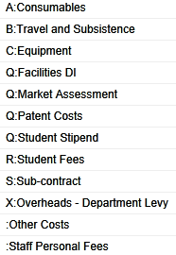

Travel and subsistence, consumables, equipment access costs are self-explanatory but it is important that you recover the full cost of each so think carefully. For costing access to equipment, a good starting point is to quote 1% of the original equipment purchase price per day. For example, I would hire out my calorimeter (cost £40,000) at £400 per day (in addition to any consumables, people time etc).

Use this section if you want to pay a student as a summer intern, for example. This is also where you can cost in a fee for yourself or a colleague (Staff Personal Fees). This will be paid to you by default through payroll, with all necessary tax and NI deductions. However, many colleagues choose to direct these funds to their ‘overheads’ accounts or their individual account so they can be used for items such as conferences fees or IT equipment (note that departments have their own guidelines on staff personal fees that you must adhere to - check with your departmental KE Director or HoD). As noted above, if the project is a consultancy then the market rate per day for an expert consultant would be expected to be at least double the Faculty Recommended Staff Day Rates given above. Hence, a similar additional amount of staff cost could be charged to the project as a Staff Personal Fee, which can be directed to payroll or otherwise. It is important to realise that if you do not do charge realistic fees you will effectively be undercutting private consultants and distorting the market.

Having got this far in establishing the COST of your KE activity, you must now consider the PRICE you wish to charge. As we wish to generate a surplus (or margin) which ‘sticks’ to the department or your own funds, we wish to PRICE at higher than the COST (i.e. we must charge a PRICE to the funder that includes, effectively, our profit margin). The Faculty requires that this surplus charge should be as a minimum 20% of the base cost (see Appendix A).

The mechanism for adding this surplus is to add it to the New Other Cost Details Section under the Cost Code *X- Overheads – Department Levy* and add the additional descriptor “Surplus”. You’ll need to do the arithmetic yourself.

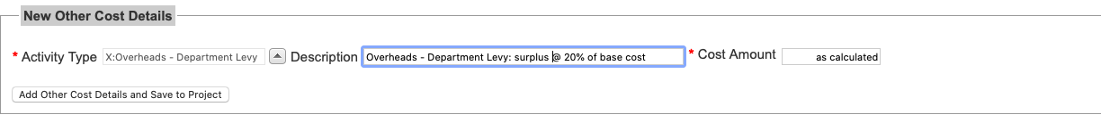

Incidentally, unlike RCUK grants, unspent money on many (but not all) KE programmes does not get returned to the funder - it will get transferred to the department or individual (depending on departmental policy) upon completion of the programme so unspent consumable or travel monies will ‘stick’. This is certainly the expectation with consultancy, CPD and similar activities for private sector organisations - the price accepted is the price paid - and savings against budget become ‘sticky’ income.

You must, finally, complete the *New Levy Cost Details* section, choosing *X:Sci/Eng* from the Cost Code drop-down menu. This will automatically calculate the Faculty levy based on the details in the previous section.



It should be noted the levy is NOT a Faculty tax on KE activity, any more than Full Economic Costing is a tax on research activity. Instead it reflects the true overheads associated with running the University and Faculty in terms of supporting purchasing, finance and contracts, IP protection, the cost of infrastructure and liability insurance etc. **In practice, the Faculty Levy is credited to the earning Department.** In any commercial contract between two companies similar costs would also be present as an overhead element, often tied up in the overall cost charged per FTE on a project. Companies will, therefore, expect to pay for these types of costs. As noted in the section on staff time recovery, the levy is charged on all costs - in the current version of KES it cannot be selectively applied to only certain elements of the costings.

Having completed the New Levy Cost Details, you will now see at the bottom of the page the total cost of the project, including the Faculty levy and VAT. Do not worry about the increase arising from the VAT element: companies will be able to off-set this against VAT they pay out.



**Present to your customer the total price and do not give them a cost breakdown** – this can be provided later in abbreviated form by RKES if necessary - **certainly do not be apologetic and say it would be only £X without the levy etc.**

Remember companies are used to paying much more than you think, although of course they will always seek to pay less! Just reflect on how much the last instrument service engineer charged just for the call-out - probably £1000 before even starting any repair. The Vice-Dean provisionally costed £80 for an analysis and then found a commercial analytical company charged £250! Indeed, most businesses will expect to negotiate downwards by at least 20% the initial quotation for your services. In fact, they often employ people whose job it is to achieve this. Hence, it is sensible to include some extra provisions in your initial pricing that can potentially be taken out to bring down the overall cost without adversely affecting the core project. If the company genuinely cannot afford to pay the price, then cut the coat according to the cloth – reduce the scale of the activity to something they can afford

Note that except in very rare cases, loss-leading prices do not work. Certainly never use them to tempt a company as the first-step in what you hope to be a continuing relationship - they will just expect it to be even cheaper next time…

The Faculty KE Team are happy to advise on any costings. Contact the Vice-Dean Knowledge Exchange, John Liggat ([j.j.liggat@strath.ac.uk](mailto:j.j.liggat@strath.ac.uk)) or your Department’s KE Coordinator.

Note that in our context cost and price can be defined as follows:

***Cost****: the monetary valuation of a) effort, b) materials, c) resources, d) time, e) utilities consumed, f) risks incurred g) opportunities forgone (e.g. writing that 4* paper, attending the grant writing challenge or recruiting an international student) to undertake the production and delivery of the knowledge exchange service.*

***Price****: the money that your customer will pay you for receipt of your knowledge exchange service , and is price is determined by a) what our customer is willing to pay, b) what we are willing to accept, and c) what the competition is charging (which will, of course, influence (a))*

*APPENDIX A*

As approved by FRAP in March 2020:

1. The price of the consultancy be cost plus surplus and levy.
2. The surplus is recommended to be **a minimum of 20% of cost**. All cost elements are included without dispensation. If a PI wishes to charge an increased surplus they can. If they wish to lower the price, they can remove the surplus with the HoD’s approval.
3. A request for the levy to be waived must be made in writing to the Vice-Dean (KE) with a clear justification (i.e. the levy cannot be waived by the HoD). The levy will not be waived where a personal fee is included in the costing.
4. Departments can set local rules regarding whether the surplus remains within the PI’s control or is transferred to Department funds.

An example costing using these principles is below:

*Recommended pricing model*

|  |  |  |  |  |  |
| --- | --- | --- | --- | --- | --- |
| Cost element | Income | Distribution | | | |
|  |  | Salary Budget | Credit to Department | Cash to Department | Cash to PI/Department |
| Established staff costs | £500 | £500 |  |  |  |
| Contract staff costs | £200 |  |  | £200 |  |
| Consumables/travel | £200 |  |  | £200 |  |
| Personal fee | £100 |  |  |  | £100 |
| Total cost | £1000 |  |  |  |  |
| Surplus (min 20% of direct costs) | £200 |  |  |  | £200[1] |
| Subtotal | £1200 |  |  |  |  |
| Levy (54% of the subtotal) | £650 |  | £650 |  |  |
| Total price to funder | £1850 |  | £650 (= 35%) | £400 | £300 |

.

1. Surplus to be split between PI and Department as per local rules.