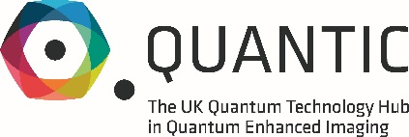

QuantIC Studentships
If you are a physicist with an interest in technology, an engineer with an entrepreneurial flare, or a theorist with an interest in applied problems, join the UK Quantum Technology Hub for Quantum Enhanced Imaging (QuantIC) and help us shape the future of imaging technology.
This postgraduate training programme is aligned with the £1 billion UK National Quantum Technologies Programme (NQTP), and is a collaborative effort led by the University of Glasgow in partnership with the Universities of Bristol, Edinburgh, Heriot-Watt, Exeter, Southampton, Strathclyde and Imperial College London, along with more than 40 industry partners.
A PhD with QuantIC offers a unique opportunity for students to undertake research in a multi-disciplinary environment between science, engineering and industry.
Designed to ensure students are equipped with the technical knowledge and transferrable skills needed for their future careers, the programme will provide an opportunity to engage with companies and academics at the forefront of Quantum Technology activities within the UK and worldwide.

The following QuantIC PhD studentships are available for application. Start date October 2021.
- PhD in Physics and Astronomy: Imaging toxic and dangerous gases using Quantum Technologies with M Squared Lasers
- PhD in Physics and Astronomy: Quantum microscopy
- PhD in Engineering with Single Quantum – mid infrared photon counting with superconducting nanowires

Entry requirements
Places will be awarded on a competitive basis. Applicants must have a 1st class or 2.1 degree at MPhys or MEng level (or equivalent) from a computing, mathematical, physical sciences or engineering programme. Exceptional candidates with BSc or BEng qualifications will also be considered.

To apply
Please submit your CV with a cover letter indicating why you are interested in the studentship to Kevin.McIver@glasgow.ac.uk

