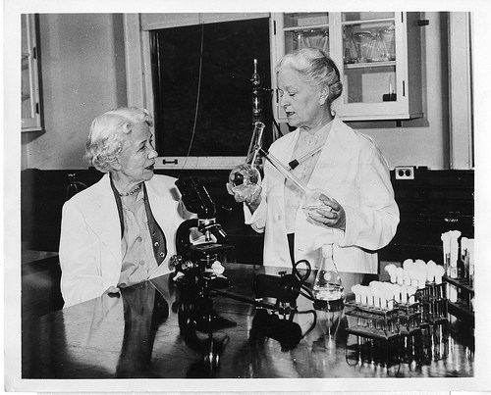

The Lass’o’pairts

The Lass’o’pairts is a ‘thing’ or series of ‘things’ for the Outdoors, a structure, an artwork, easily moveable, audience and performer interactive, with pieces that can be manipulated, that pop-up, spring out, react, move, play, that sound, that are tactile.

It tells the stories or mirrors discoveries, inventions and creations that Women have made in Cosmology, Computing and the Arts.

It is magical and fun, weather resistant and robust.

It (or they ) will be created by women Artists, designers and makers.

It will attempt to communicate with the public through all the senses, creating something that can be accessed by many types of people.

**Artist Brief**

Mischief La-bas are inviting up to 5 x Artists to take part in our initial exploration and development stages.

To take place in Glasgow between February and April 2019

1 x day prep – reading briefs and collated materials and research from Angie Dight ( Artistic Director )

2 x days at Cadogan House Glasgow 10 – 7pm

1 x day to collate and work individually on ideas, drawings etc.

3 x days to create prototypes, models with the whole group, collaboratively or individually at Cadogan house, a sound or film studio or workshop.

**Scientists , Engineers, Explainers and Advisors**

As non - Scientists or Engineers we are inviting women from the field of Science and Engineering to speak to us at the initial stages of the project to advise, illustrate, enlighten , explain to us about Women and their discoveries, inventions, work etc throughout history and now.

We would like to focus on a broad section of women ( ie not just American and Western women )

We are particularly interested in the discoveries, inventions , work of women that we can illustrate by creating 3D artworks, animations, films, sound ‘kaleidoscopes’, things that move.

We hope also that in the making of such things, we will find inspiration from Women Artists and ‘Creators’ who have also been less recognised throughout history.

There may be another paid development stage before further funding is required for the piece to be commissioned as a piece of interactive performance and produced for Touring in 2020.

The Lass’o’pairts Research and Development is funded by Without Walls Blueprint, R&D programme ( as Herstory ) and Creative Scotland (Mischief La-bas RFO transition )